|  |  |
| --- | --- |
| **Exp.No :**  **Date:** | **Creating a webpage using imagemap** |

**AIM:**

To create a simple webpage using imagemap.

**DESCRIPTION:**

This webpage is created to demonstrate South Inidan meals. If we click a specific dish it redirects us to the respective page which contains facts or information about the dish. For that we are using a tag called “MAP” which defines the clickable areas in the image map.

**PROCEDURE:**

|  |  |
| --- | --- |
| Tags used | Description & its Attributes used |
| <html> | Represents the root of an HTML document. |
| <head> | It is the container for metadata |
| <title> | Defines a title in the browser toolbar. |
| <body> | It contains all the contents of an HTML document. |
| <img> | Defines an image in an HTML page.  Attributes used: |
| * width specifies the width of an image. * Usemap - Specifies the image as a client-side image map |
| * src - Specifies the path to the image |
| * alt Specifies an alternate text for the image, if the image for some reason cannot be displayed |
| * height - Specifies the height of an image. |
| <map> | Used to define an image map.It is an element contains a number of elements that defines the clickable area in the image map. |
| Attributes used:   * name - It is Required and it Specifies the name of the image map. |
| <area> | Defines an area inside an image map. |
| Attributes Used: |
| * alt - Specifies an alternate text for the area. Required if the href attribute is present |
| * coords - Specifies the coordinate of the area |
| * href- Specifies the hyperlink target for the area |
| * rel - specifies the relationship between the current document and the target URL |
| * shape - Specifies the shape of the area |
| target | Specifies where to open the target URL |
| <h1> to <h6> | Used to define the HTML headings. |
| <p> | Used to define a paragraph. |

**PROGRAM:**

<!DOCTYPE html>

<html>

<body>

<h2>Image Maps</h2>

<p>Click on any of the dishes to go to a new page and read more about the topic</p>

<img src="imgmap.jpg" alt="Workplace" usemap="#workmap" >

<map name="workmap">

<area shape="circle" coords="112,31,20" alt="Sambar" href="https://en.wikipedia.org/wiki/Sambar_(dish)">

<area shape="circle" coords="160,29,18" alt="Dal" href="https://www.cookingandme.com/category/dal-recipes/">

<area shape="circle" coords="199,38,20" alt="Payasam" href="https://en.wikipedia.org/wiki/Kheer">

<area shape="circle" coords="69,42,18" alt="Rasam" href="https://en.wikipedia.org/wiki/Rasam_(dish)">

<area shape="poly" coords="121,157,127,160,131,164,135,169,141,171,148,175,155,173,163,171,170,171,176,168,183,166,189,156,194,144,195,151,192,137,188,129,181,123,174,121,166,117,160,117,153,117,142,118,137,118,132,119,125,119,122,123,119,129,117,136,116,143,117,149" alt="Rice" href="https://en.wikipedia.org/wiki/Rice">

<area shape="poly" coords="39,137,41,143,45,147,49,151,54,157,57,161,63,164,69,161,74,163,79,157,82,147,86,141,92,137,40,129,45,123,49,117,55,114,61,114,67,110,73,109,79,108,84,109,89,112,91,117,94,122,95,127" alt="Pappad" href="https://en.wikipedia.org/wiki/Papadam">

</map>

</body>

</html>

**Image Map**

**Click on different sections in image to explore.**

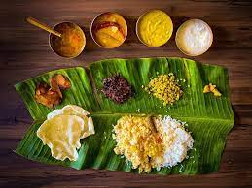

**Home Page:**

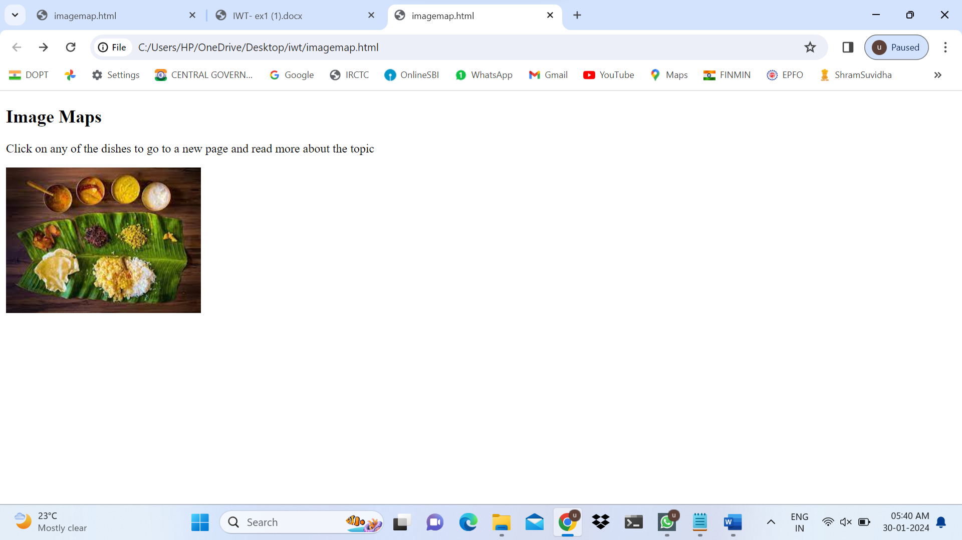

**On Clicking Rasam:**

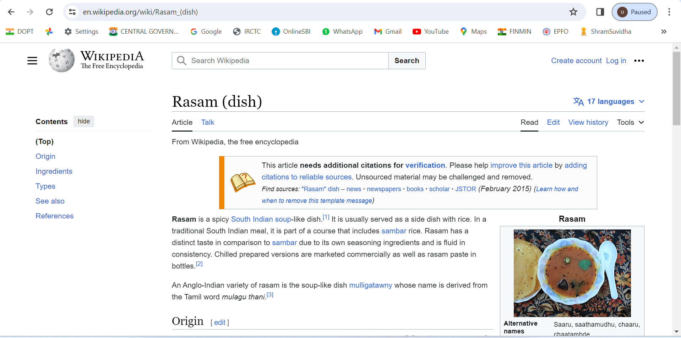

**On Clicking Sambar:**

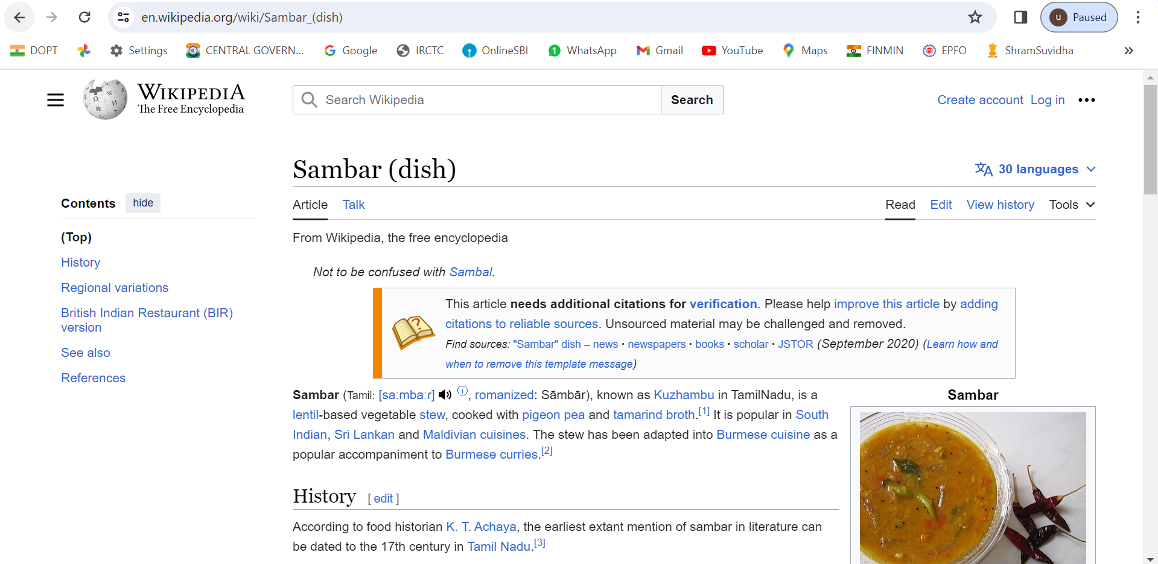

**On clicking Rice:**

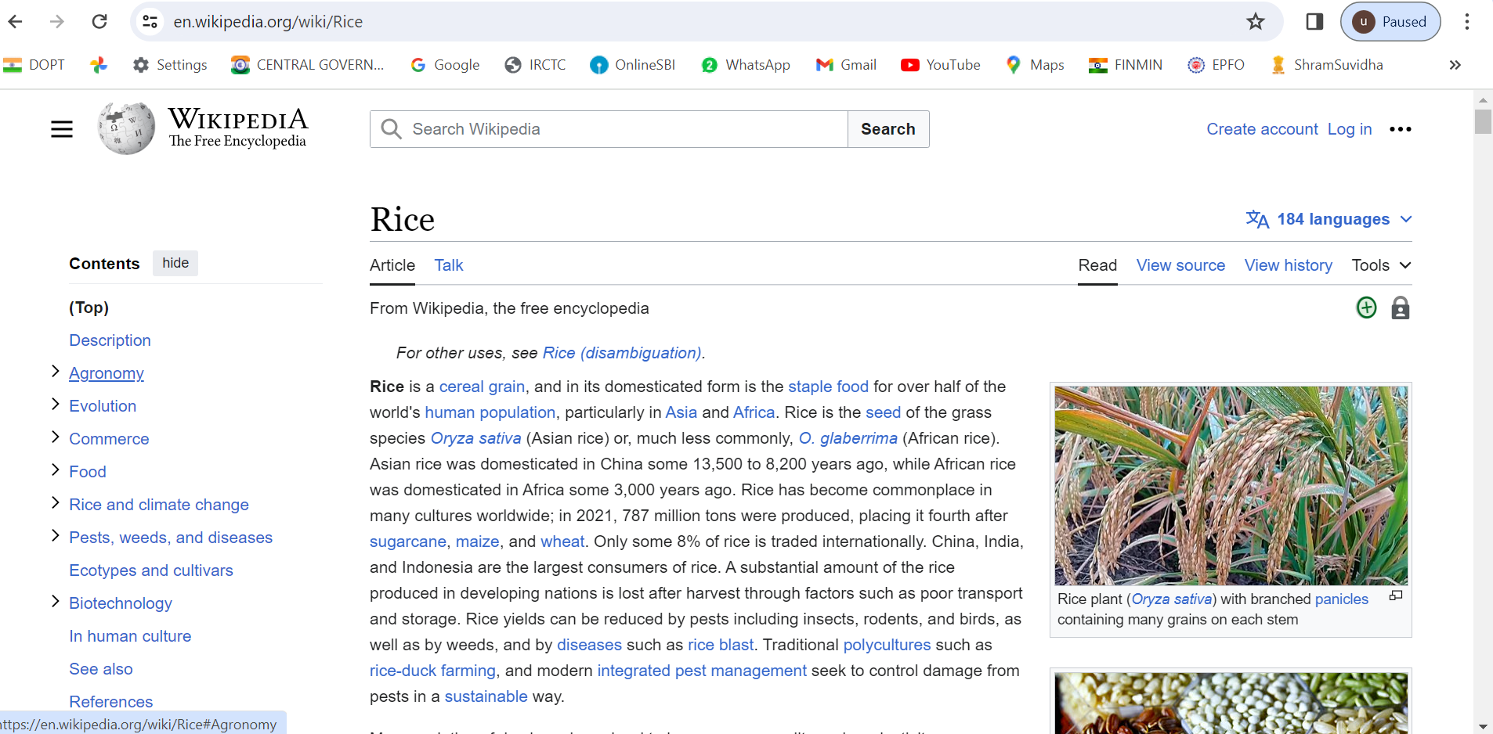

|  |  |  |  |  |
| --- | --- | --- | --- | --- |
| **Problem understanding**  **(5)** | **Implementation and output**  **(5)** | **Viva**  **(5)** | **Time management**  **(5)** | **Result**  **(5)** |
|  |  |  |  |  |

**RESULT :**

Thus the webpage using HTML tags that redirects with respect to the image which is clicked was created and the output was verified.